Overview:
A utility that sets a property to the path that a folder lives in.
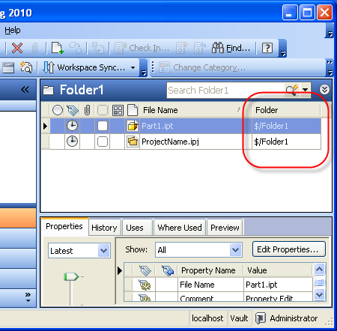
Requirements:
Vault Workgroup/Collaboration/Manufacturing 2010
Click here to get the application
Click here to get the source code
Introduction:
I've had a few requests for this one. Since it was a pretty cool idea and not too hard to write, I decided to go for it. Don't ever say that I never did anything for you.
Under the hood, this is just a re-write of Vault Mirror. Just like with Vault Mirror, this utility can be run from the task manager. And this utility also has 2 operation types. There is a "quick mode" that only works on new files and a "slow mode" that scans every file in the Vault. The recommendation is to create a Windows scheduled task that runs every 10 minutes or so which keeps things mostly in sync.
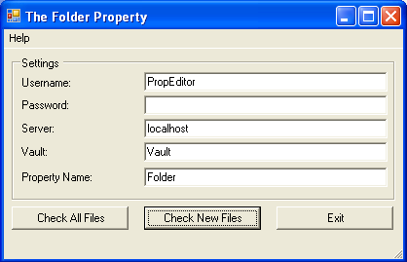
There are a few differences however. The Folder Property is not as reliable as Vault Mirror. Because locked files can't be edited, you will find that several files won't have the property set.
Another difference is that The Folder Property edits data, so it consumes a license while it is running. To mitigate the impact, the utility only consumes a license during the actual file editing. When scanning for files, no license is consumed. Once all the edits are made, the utility frees up the license.
See the readme file for additional instructions and command line parameters.
Enjoy!

